W9 - PRACTICE
Going deeper with states

 At the end of his practice, you should be able to…
- Reflect on your usage of states
- Style widgets dynamically
- Pass functions as value to props
- Handles objects in states
  - Treat state as read-only
  - Copy objects with the spread syntax

 How to work?
- Download the start code from the Google classroom
- For each exercise you can either:
  - Run npm install
  - Or move an existing node_modules to the exercise folder (fastest option!)

How to submit?
- Create a repository on GitHub with the name of this practice:
Ex: C2-S6 PRACTICE
- Push your final code on this GitHub repository (if you are lost, follow this tutorial )
- Finally submit on Google classroom your GitHub repository URL
Ex: https://github.com/thebest/ C2-S6 PRACTICE.git

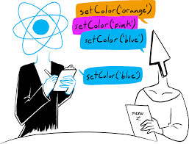
 Are you lost?
You can read the following documentation to be ready for this practice:
https://www.w3schools.com/react/react_events.asp
https://react.dev/learn/updating-objects-in-state

EXERCISE 1
You can click on this link to see the expected results for this exercise:
https://react-s11-ex1.vercel.app/

The goal of this app is to update the progress bar, according to the value entered in the input field:
    - Values range are from 0 to 10
    - Progress bar color changes depending on the score (see bellow)

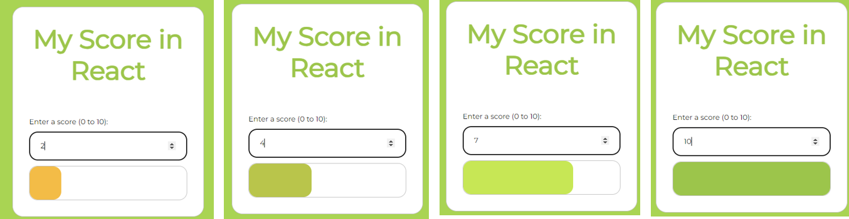
Depending on the score value (0 to 10) the progress bar with and color shall be updated

Step 1: What is/are the state(s) you plan to use for this exercise? Complete the table.

State Name | Type | Role | Used for… | Changed when…
score | Number | Manage the range of the value | Store the current value and update score bar width. | User input or decrease, increase from 0 to 10.

Step 2: Update the progress bar width according to the score value

Tips: The progress has 2 div: the border rectangle and the filled rectangle. Which one should you update?

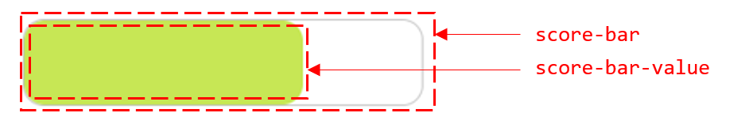

Step 3: Update the progress bar color according to the score value

EXERCISE 2
You can click on this link to see the expected results for this exercise:
https://react-s11-ex2.vercel.app/

The user can specify an object name and price. By clicking on Add, this object shall be added to the list.

Step 1:
Look at the start code. We have 3 components.
- App manages a state with the list of objects
- StuffCard displays 1 object (nothing to change on this component!)
- StuffForm manages the form and send an event when user has click on Add

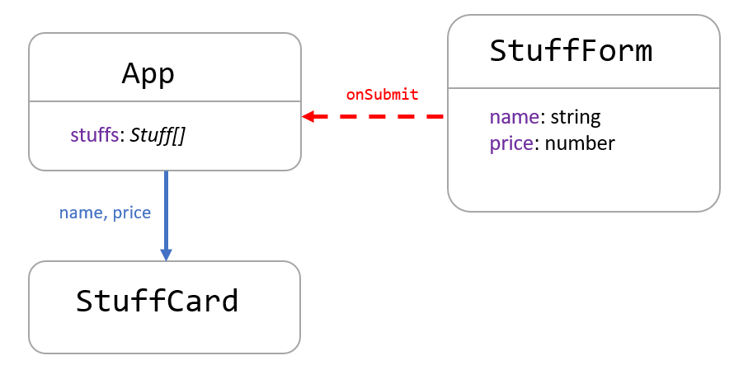

Complete the StuffFrom to handle the input values with the following states:
State | Type | Component | Used to… | Changed when…
name | String | StuffFrom | Store the entered name | Input name had changed
price | number | StuffFrom | Store the entered price | Input price had changed

Step 2:
When user clicks on Add button, the StuffFrom component sends an event to the App component
Complete the code to send this event, with the entered name and price as parameter

Note: For now, just log something on the console to check you can manage the event on App component. For example:

A new object named Piano, price 15$ will be added to the list

Step 3:
The last step is to update the state containing the stuff, with the new object.
State | Type | Component | Used to… | Changed when…
stuff | Array | App | Storing all stuffs | Add a new stuff

 First read the following articles about objects and arrays in state:
- https://react.dev/learn/updating-objects-in-state
- https://react.dev/learn/updating-arrays-in-state

Q1 – Why states containing an array or an object should be treated as read only?
React uses state changes to detect when the UI should update.
If we modify an object or array directly, React may not detect the change, and the component may not re-render correctly.

Q2 – Why do we need to create a new array when we want to add a created object to a state array?
To follow React’s immutability rule.

Q3 – What is the spread operator? How can you use it to clone the state array and add the new created object?
The spread operator (...) copies elements of an array or object. In React it is used to create a new array when updating state.

Q4 – Then complete the code to update the state array with the new object.

The finished app will look like this:

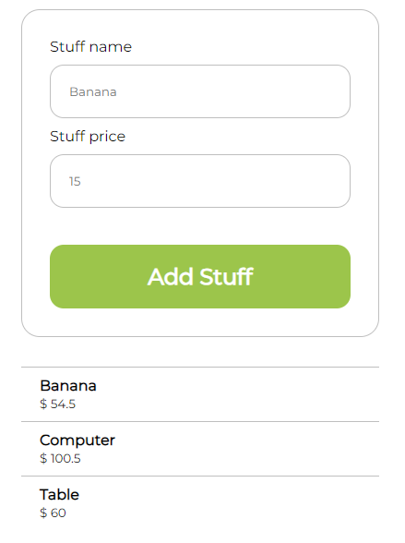

EXERCISE 3
You can click on this link to see the expected results for this exercise:
https://react-s11-ex3.vercel.app/

This app allows the user to adjust the quantity of items to buy and to compute the total price.
Note: the minus button is disabled when the quantity is equal to 0.

The finished app will look like this:
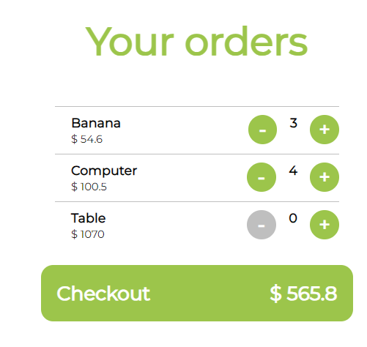

Step 1:
Look at the start code. We have 3 components.
- App manages a state with the list of items
- Order Card handle the quantity to order for 1 item
- CheckoutButton displays the total sum (nothing to change on this component!)

Q1 - What is/are the state(s) you plan to use for this exercise? Complete the table.
State Name | Type | Component | Used for… | Changed when…
orders | array | app | Stores all items with their product name, price and quantity | Use click – or +

 Tips: Is the total price a state?

Q2 - What are the interactions you plan to define between the components?
Complete the diagram: purple=states, blue=props data, red=prop event

 Tips: what’s happen when you press + or – button on an item card? Which component will handle the state update?

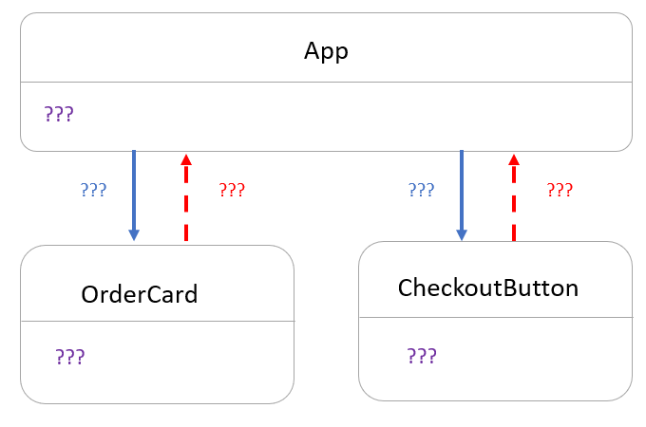

Q3 – Update the code to display each item using OrderCard components (name, unit price and current quantity)

Note: For now, the + and – button do not work!

Q4 – Update the code to send the right total price to the CheckoutButton

Tips: It’s always good to separate our code with clear functions!

Q5 – When user click on + or - the quantity of the related item must change, and also the total price

- Which state needs to be updated? Which component manages this state?
orders, App

Tips: you don’t know how to update a state array?
- Read again this document (section Replacing items in an array)
- Understand how to use the non-mutating methods map and spread operation to perform this operation.

Q6 – When quantity is equal to 0, the minus button shall be disabled on the order card.

To effectively disable the button, we need to display it gray but also prevent any action when clicking on it.

Therefore, when quantity is equal to 0:
- The minus button background is gray (#bfbfbf)
- No action can be done when clicking on minus button

